**Homework 1: Face Detection**

**Report Template**

**Please keep the title of each section and delete examples. Note that please keep the questions listed in Part III.**

**Part I. Implementation (6%):**

* **Please screenshot your code snippets of Part 1, Part 2, Part 4, and explain your implementation. For example,**

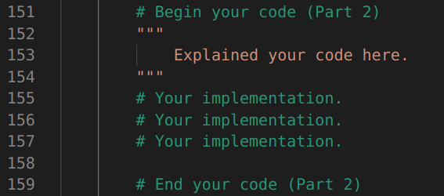

**Part II. Results & Analysis (12%):**

* **Please screenshot the results. For instance,**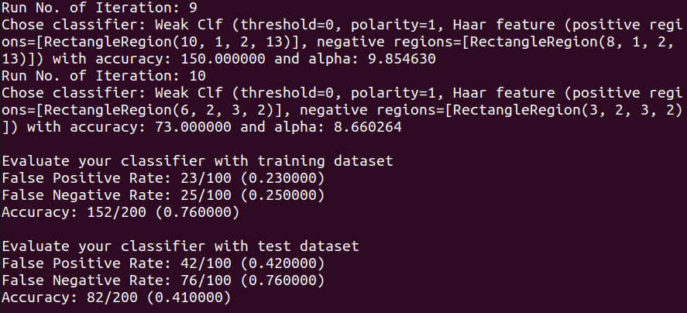

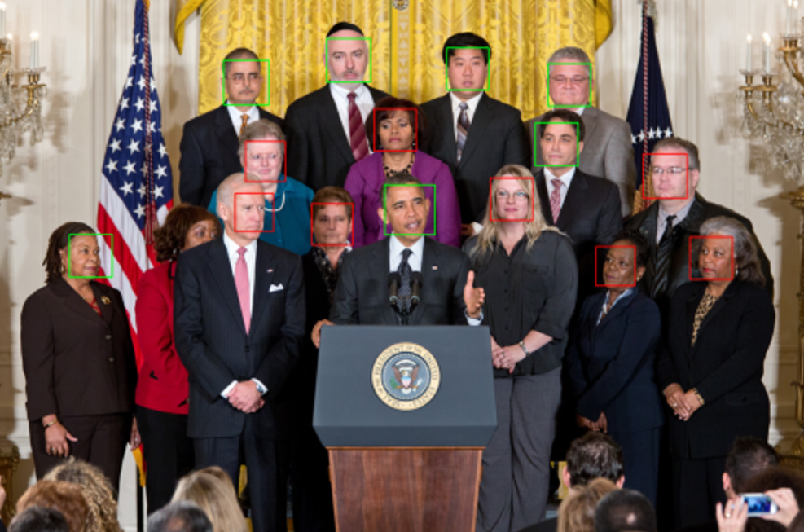

* **Your analysis or observation.**

**Please discuss the performance difference between the training and testing dataset, and present the results using a table or chart as follows.**

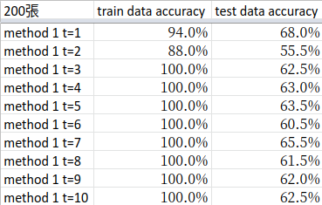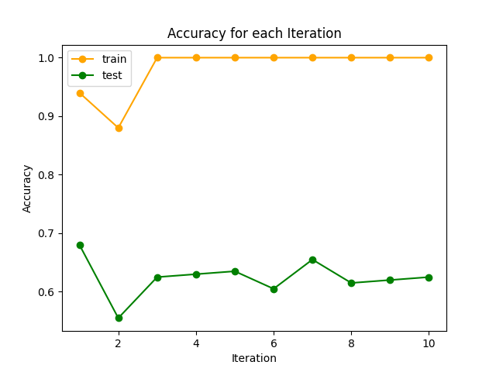

**Part III. Answer the questions (12%):**

1. Please describe a problem you encountered and how you solved it.
2. What are the limitations of the **Viola-Jones’ algorithm**?
3. Based on **Viola-Jones’ algorithm**, how to improve the accuracy except increasing the training dataset and changing the parameter T?
4. Please propose another possible **face detection** method (no matter how good or bad, please come up with an idea). Please discuss the pros and cons of the idea you proposed, compared to the Adaboost algorithm.